

NAME: ROSE BRENDA GATHONI
ADM NO: BSCCS/2024/56764
COURSE: BACHELOR OF SCIENCE IN COMPUTER SCIENCE
UNIT CODE: BIT3208
UNIT NAME: ADVANCED WEB DESIGN AND DEVELOPMENT
SEMESTER/ACADEMIC YEAR: SEM 2, YEAR 3

PRIJECT TITLE: MKUHUB
SELECTED TECHNOLOGIES: PHP + MYSQL
GITHUB LINK: https://github.com/gathonimumbi23/CampusHub.git

Table of Contents
Week 1: Local Environment Setup 1
Title: Installation and Testing of Local Development Environment 1
Figure 1: Installation of XAMPP 1
Figure 2: Apache and MySQL Running 1
Figure 3: Localhost Test Page 1
Figure 4:Hello World Test 2
Figure 5:Database Connection Test 2
Student Reflection -Week 1 2
Week 2: Wireframes and GUI Design 3
Title: User Interface Planning and System Design 3
Figure 6: Hand-drawn Wireframe 3
Figure 7 and 8: Dashboard Layout Design 3
Figure 9 and 10: Dashboard Layout Design 5
Figure 11, 12 and 13 Color Theme and Navigation Structure 6
Figure 14 and 15 GUI Prototype 7
Student Reflection- Week 2 8
Week 3: JavaScript and PHP Basics 8
Title: Frontend Interaction and Backend Foundations 8
Fig 16: JavaScript Form Validation 8
Fig 17: Password Strength Checker 9
Fig 18: PHP Syntax Practice 9
Fig 19: Database Connection Script 10
Fig 20: Dynamic User Input Handling 10
Student Reflection - Week 3 11
Week 4 11
Main Goal: Introduce dynamic backend processing and real user interaction systems. 11
Fig 21: Login form screenshots 11
Fig 22: Form validation screenshots 12
Student Reflection- Week 4 14
Week 5 Theme of Week 5: Database Components and CRUD Operations 14
Fig 26: Database screenshots 14
Fig 29: Login database integration screenshots 15
Student Reflection- Week 5 17

Week 1: Local Environment Setup

Title: Installation and Testing of Local Development Environment

Figure 1: Installation of XAMPP
The figure show successful installation of XAMPP
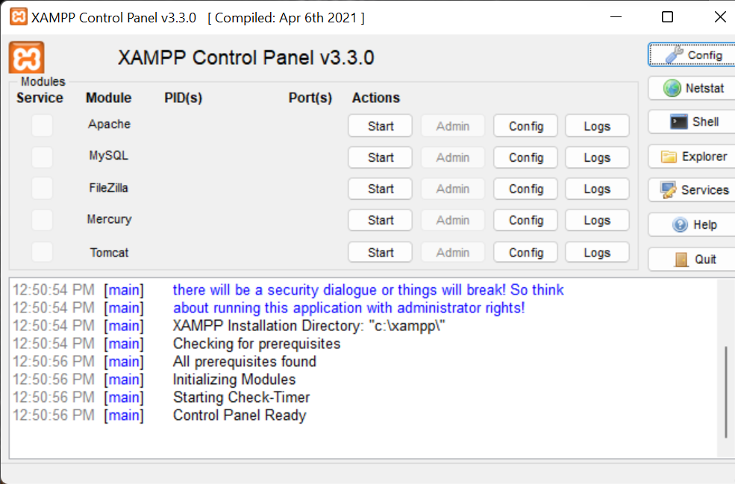

Figure 2: Apache and MySQL Running
The figure shows Apache and MySQL runs successfully. This show the figure 1 is true.
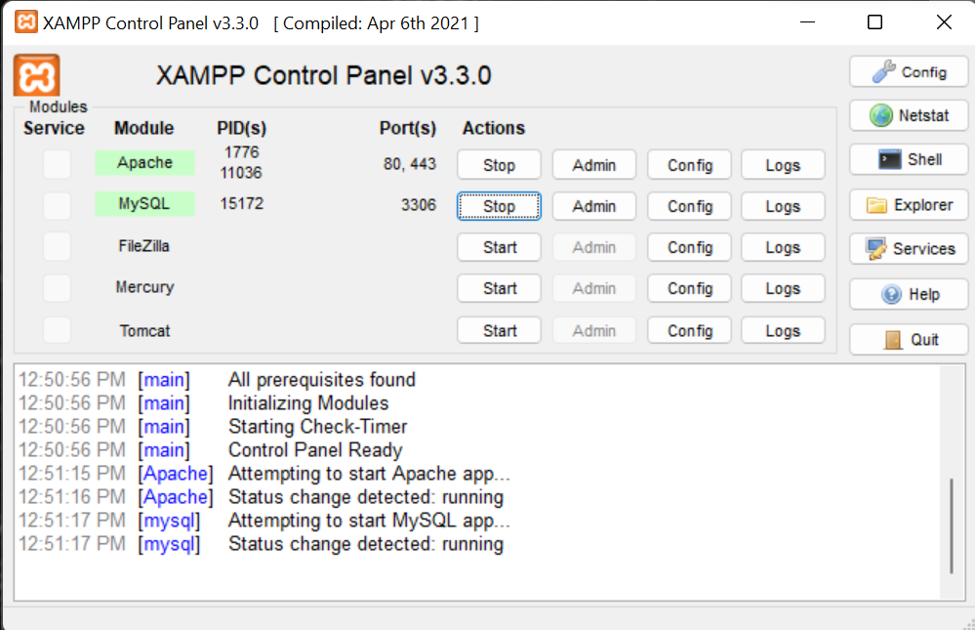

Figure 3: Localhost Test Page
The figure shows localhost/test/index.php runs successfully. This shows database and php are well connected.
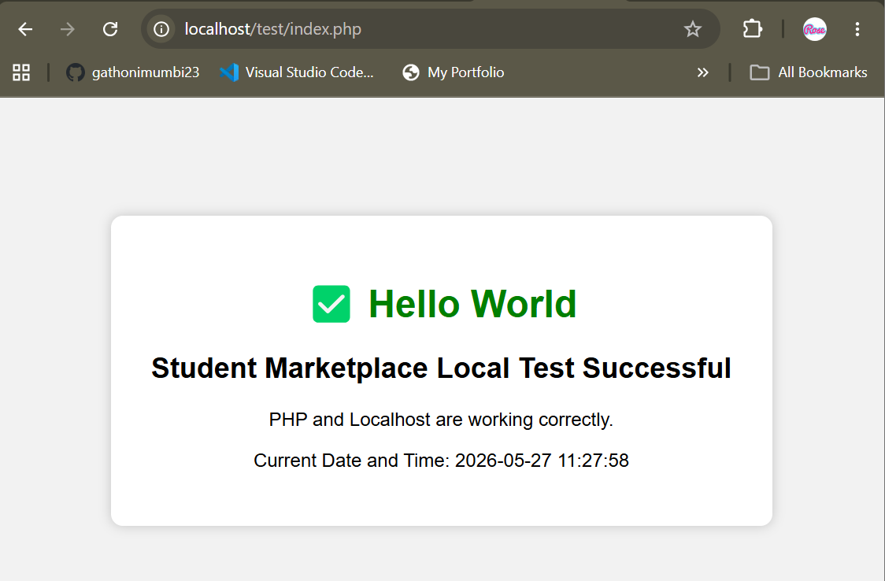

Figure 4:Hello World Test
The figure show our code runs successfully


Figure 5:Database Connection Test
The figure shows the database connects successfully
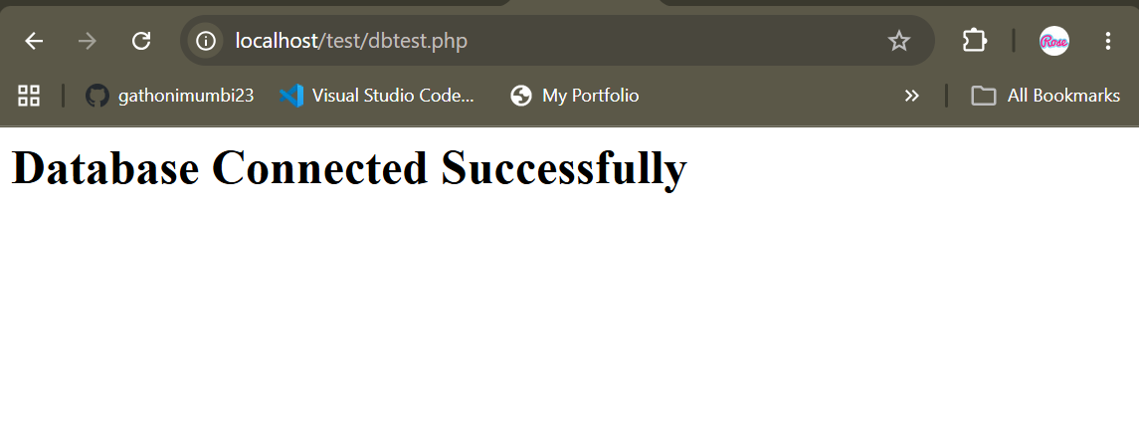

Student Reflection -Week 1
During this task, I learned how to set up a local web development environment using XAMPP and how to run Apache and MySQL services successfully. I also learned basic PHP concepts, including creating a simple Hello World page and testing localhost through the browser. Additionally, I practiced connecting PHP to a MySQL database using phpMyAdmin. The technologies used included XAMPP, PHP, MySQL, and Google Chrome. One challenge encountered was configuring localhost and understanding database connections. The screenshots demonstrate successful installation, server execution, webpage rendering, and database connectivity within the local development environment

Week 2: Wireframes and GUI Design

Title: User Interface Planning and System Design

Figure 6: Hand-drawn Wireframe
The figure below show the wireframe of the register, login, customer and seller page.
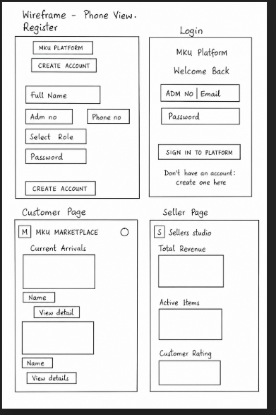

Figure 7 and 8: Dashboard Layout Design
The figure show the seller and customer dashboard ( which are the main dashboards) mockup design
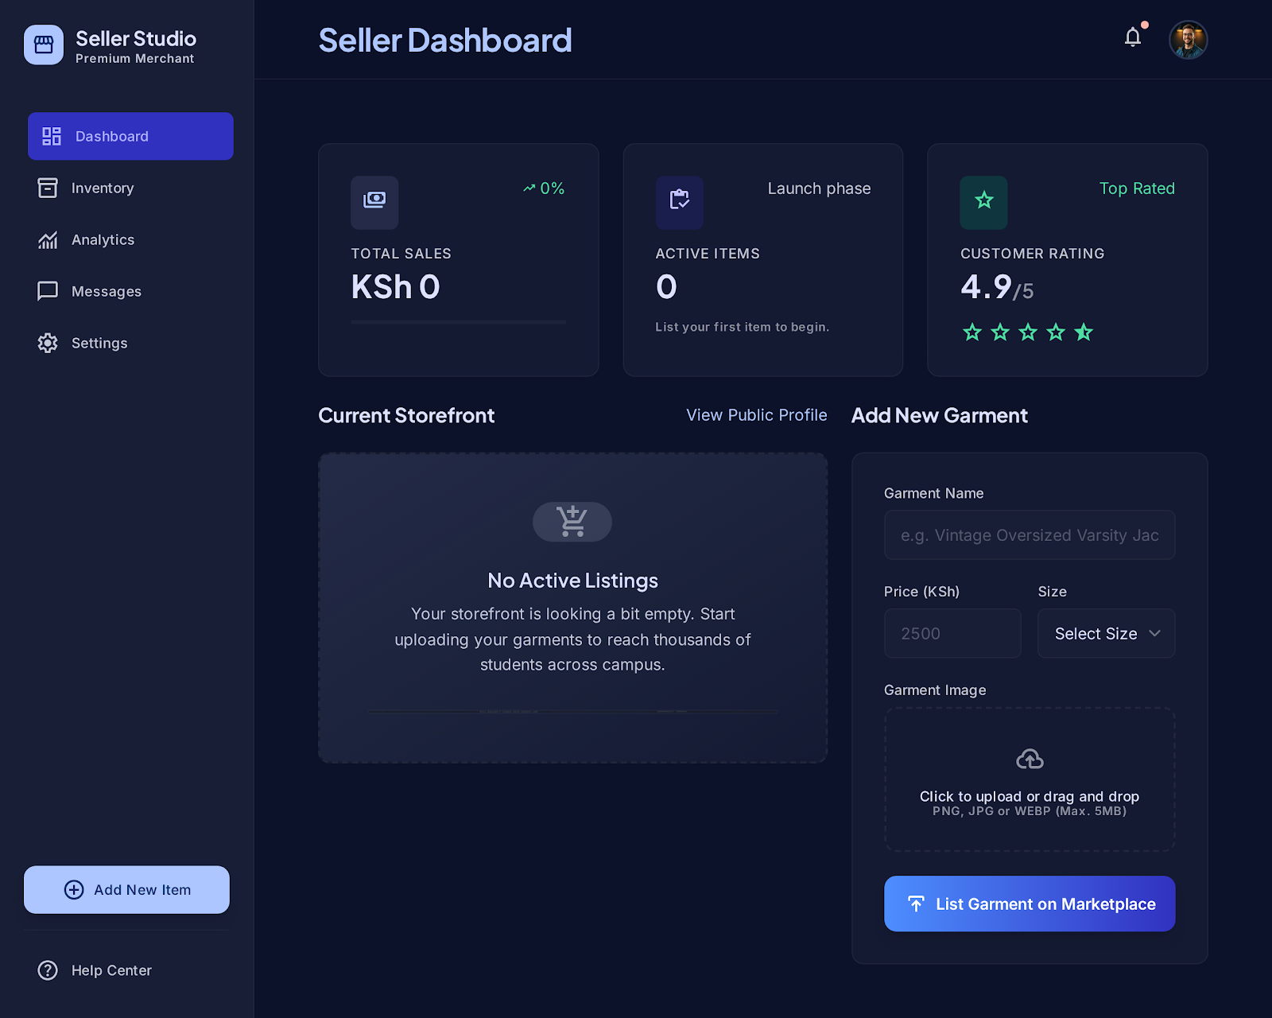
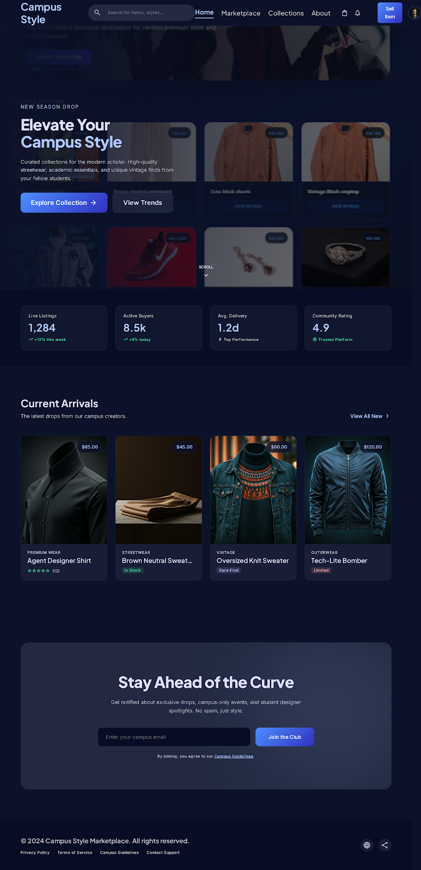

Figure 9 and 10: Dashboard Layout Design
The figures shows the mobile mockup of both dashboards


Figure 11, 12 and 13 Color Theme and Navigation Structure
The figures below shows the theme color (a glassy blue and purple themed colors) and the navigation structure( from register to login to either customer or seller dashboard depending on the role chosen)
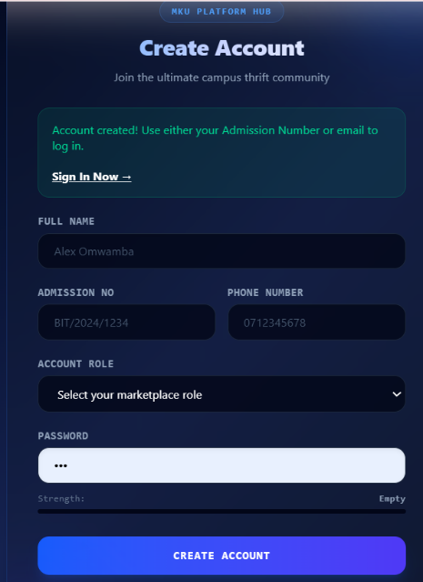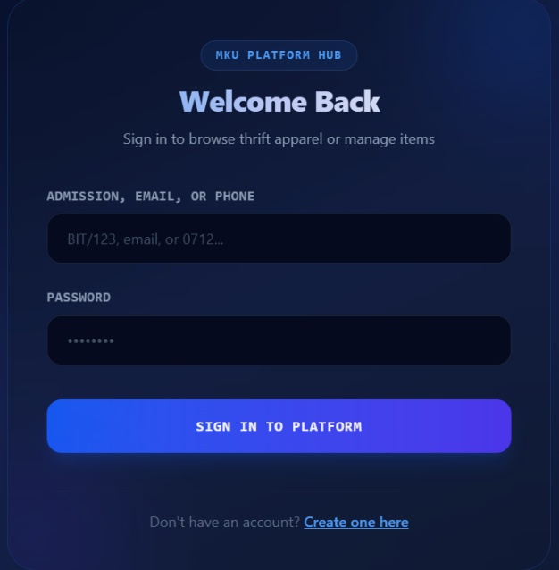
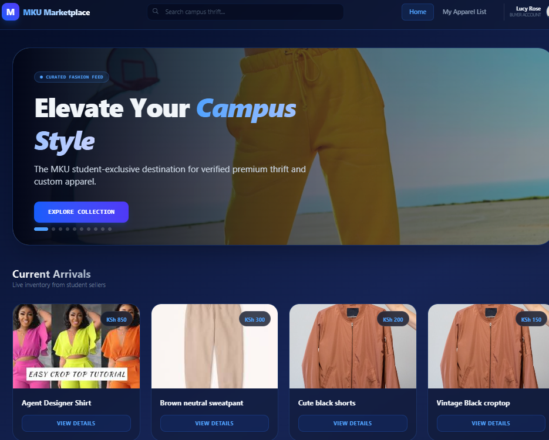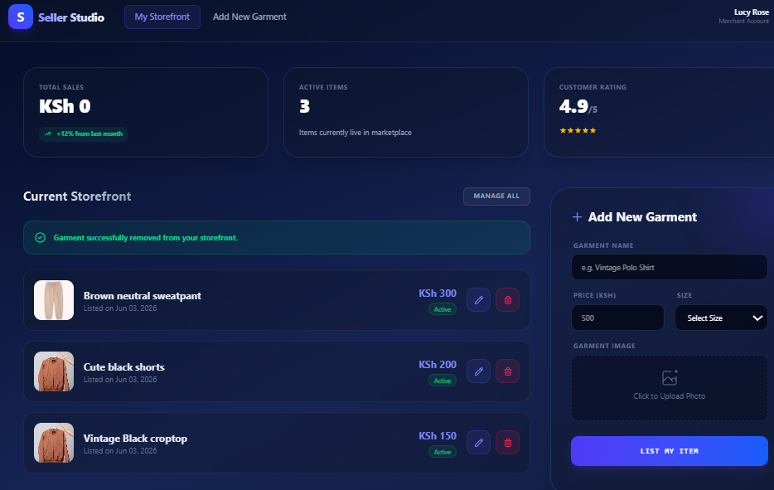

Figure 14 and 15 GUI Prototype
The figure show the GUI of the system and its user friendliness
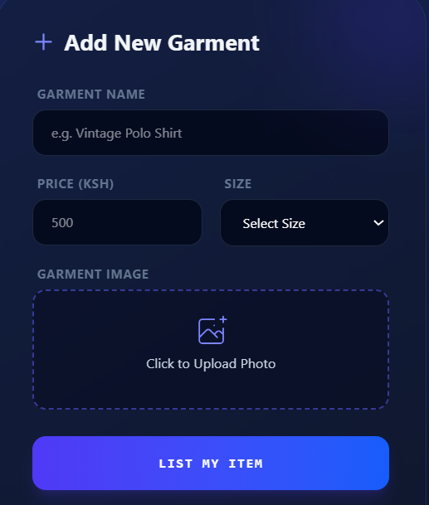

Student Reflection- Week 2
The two-column layout for the login and registration pages was deliberately selected to create an immediate visual impact. The left side features an illustrative panel with floating badges showing active listings and community size, designed to motivate and entice students into clicking the login or registration button. Purple was chosen as the primary color theme for its gender-neutral appeal, making the marketplace welcoming to all students regardless of background. Navigation flow was planned around the student journey from landing on the homepage, browsing categories, viewing listings, and proceeding to authentication. MKU Market Place is intended exclusively for Mount Kenya University registered students.

Week 3: JavaScript and PHP Basics

Title: Frontend Interaction and Backend Foundations

Fig 16: JavaScript Form Validation
The figure shows admission number and school email can only be used to register once
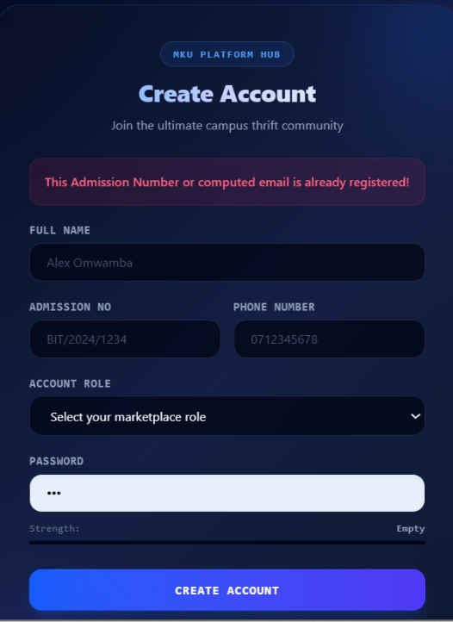

Fig 17: Password Strength Checker
The figure shows an indicator of weak or strong password
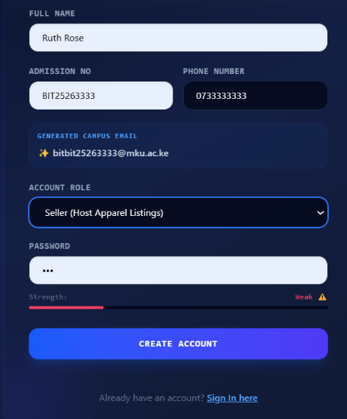

Fig 18: PHP Syntax Practice
The PHP code was used for practice
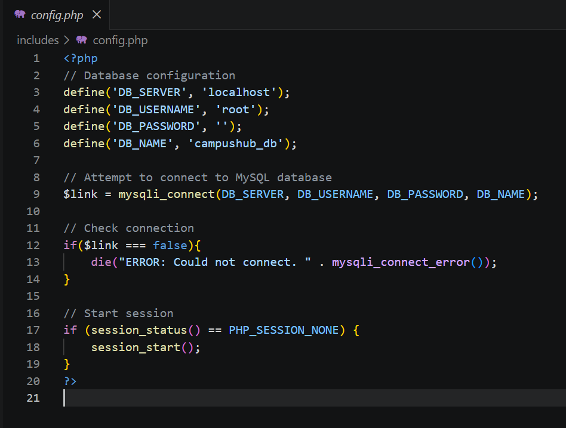

Fig 19: Database Connection Script
The code below is the main code used in the system
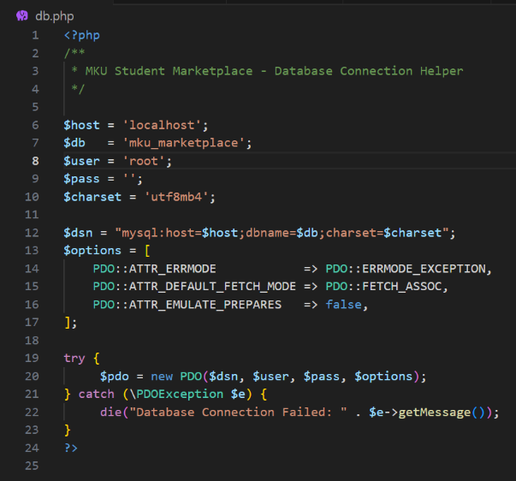

Fig 20: Dynamic User Input Handling
The figure represent the Hero-carousel which is seen in the system


Student Reflection - Week 3
JavaScript validation was implemented to intercept empty form submissions before data reaches the server. When a user submits the login form with empty fields, JavaScript immediately displays inline error messages for the email and password fields, improving user experience without a page reload. PHP was then used to process validated form data on the server side, handling authentication and database queries. Passwords are stored as ciphertexts rather than plain text for security, if the database were compromised, passwords remain unreadable. The MySQL database connection is critical without it, no data displays and the server returns errors. Technologies used include JavaScript, PHP, and MySQL.

Week 4

Main Goal: Introduce dynamic backend processing and real user interaction systems.

Fig 21: Login form screenshots
The figure show the login page of the system
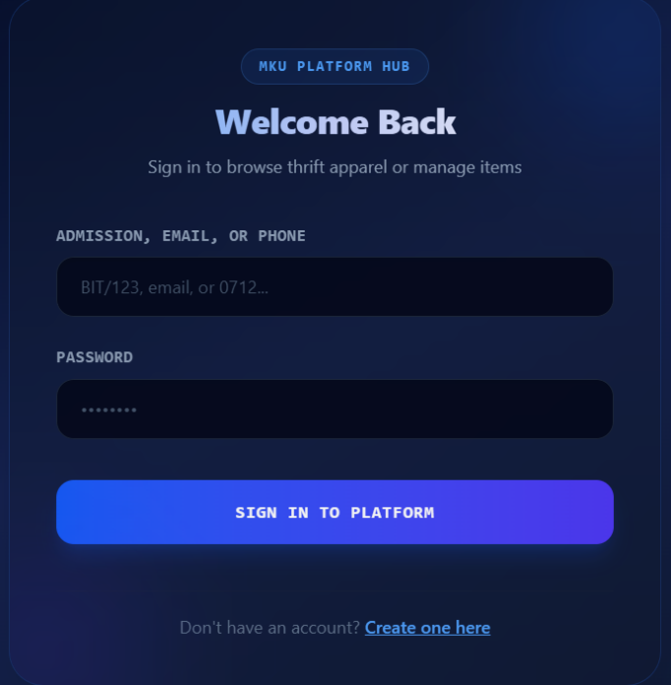

Fig 22: Form validation screenshots
The figure shows a successful registration
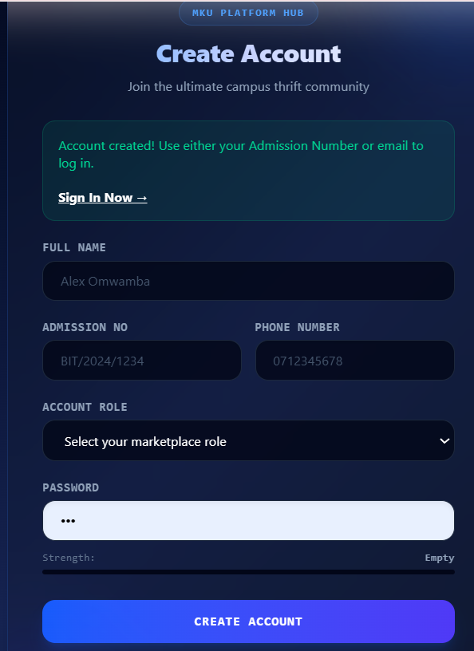
Fig 23: Folder structure screenshots
The figures show the structure of the folder of the MKU-marketplace
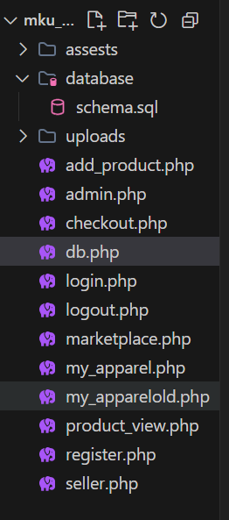
Fig 24: Database connection screenshots
The figure below show the code used for database connection
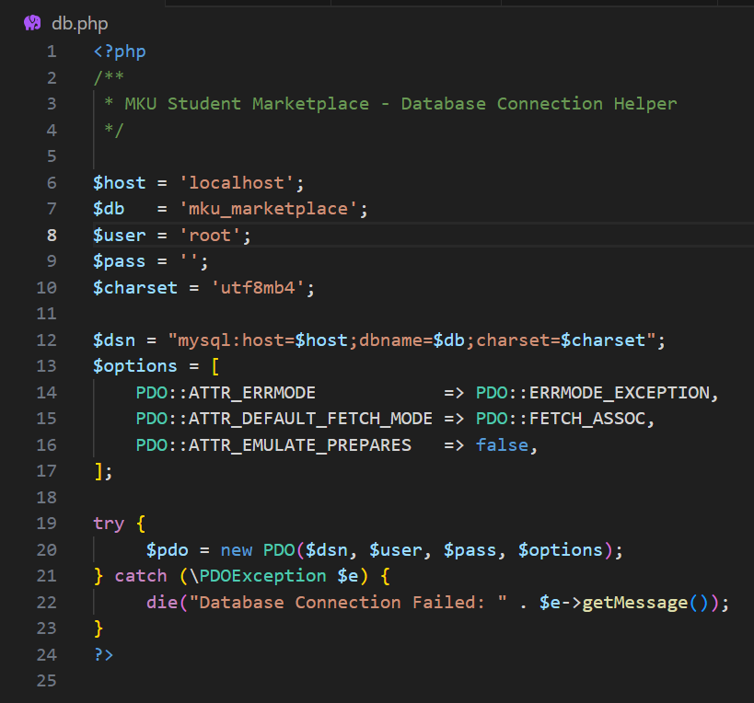
Fig 25: GitHub updates
The figure shows update of the system in the version control- github
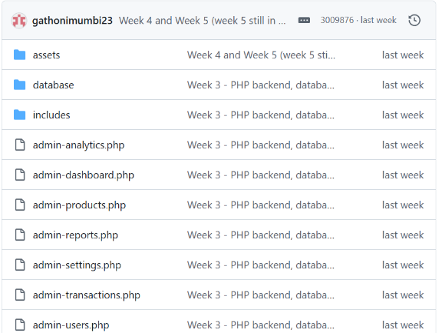

Student Reflection- Week 4
This week, I successfully transitioned from static frontend design to dynamic backend processing using PHP. I learned how to handle user data securely through POST methods and implemented a functional registration and login system. Understanding the request response cycle and managing user sessions was a breakthrough it allowed me to maintain user states across different pages. By organizing my project files into a professional structure and integrating these features, I gained practical insight into how server-side logic powers real-world applications like e-commerce and SaaS platforms. I now feel confident in my ability to build interactive, authentication-ready web interfaces.

Week 5
Theme of Week 5: Database Components and CRUD Operations

Fig 26: Database screenshots
The figure show the database created for the MKU-marketplace
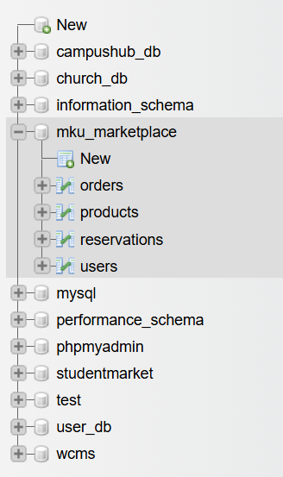
Fig 27: Table creation screenshots
This figure shows tables of the MKU_marketplace system
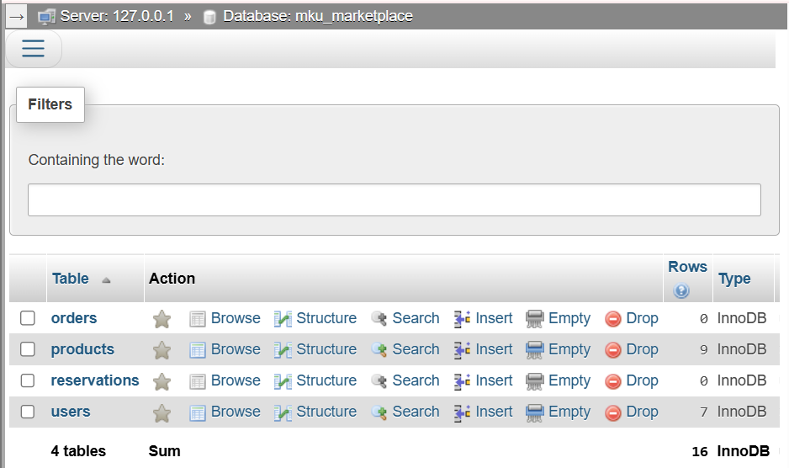
Fig 28: CRUD operation screenshots
The figure shows the items ca be manipulated( edited or deleted)
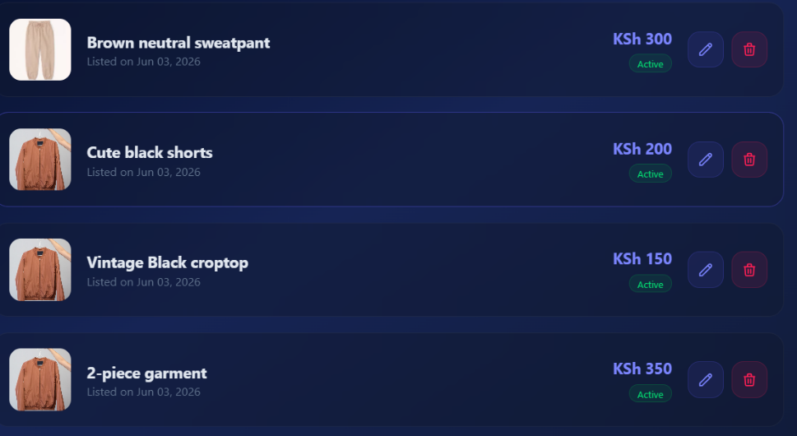

Fig 29: Login database integration screenshots
The figure represent the login code, saved as login.php
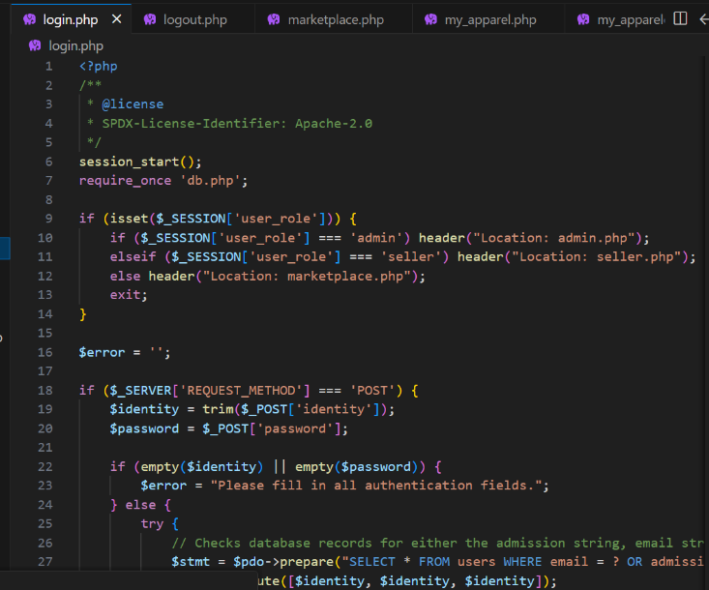
Fig 30: SQL query screenshots
The code represent the SQL used in the system saved as schema.sql
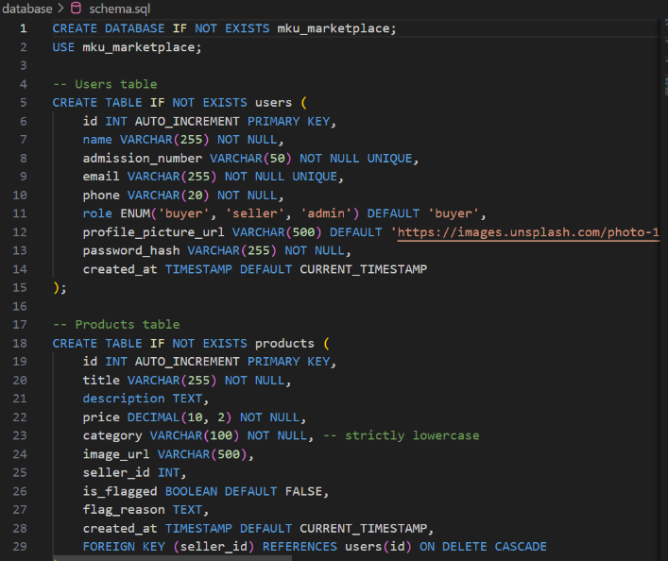
Fig 31: GitHub updates
The figure shows changes were pushed to the github

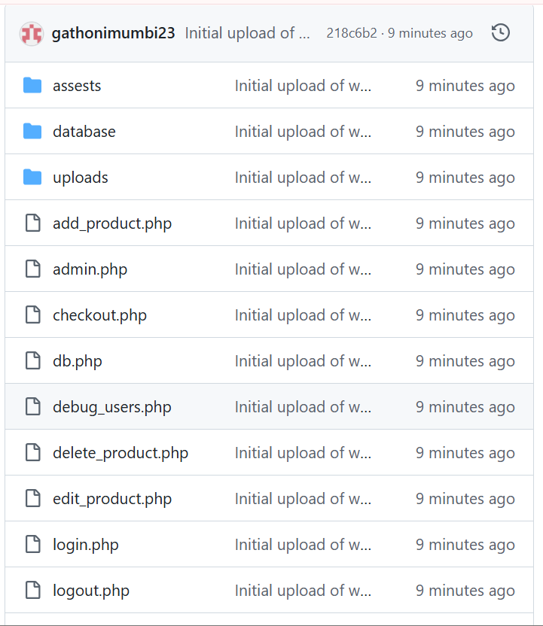

Student Reflection- Week 5
I integrated database driven functionality into my project. I learned to create relational databases in MySQL and perform essential CRUD operations to manage data dynamically. By connecting my PHP backend to the database, I enabled the system to store, retrieve, and update user records in real-time. This week’s focus on the MVC (model-view-controller) like data flow from SQL queries to frontend display greatly enhanced my full-stack development skills. Managing incremental backups and SQL exports taught me the importance of version control and professional data integrity, which are critical habits for maintaining robust, enterprise-grade software systems.

